User Manual of the Money Converter App:

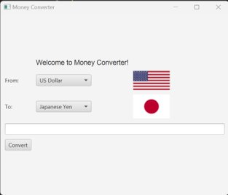

When opening the app it will have a welcome message, a choice box for the “from” currency, a flag for the “from” currency, a choice box for the “to” currency, a flag for the “to” currency, a text box to type the number, and a Convert button.

How to use Money Converter:

* The first step to being able to use the Money Converter app is to click on the "from" choice box to select the currency that you want to convert from and then clicking the "to" choice box to choose the currency you want to convert to.

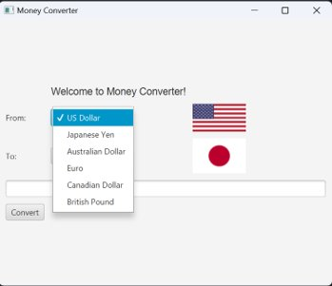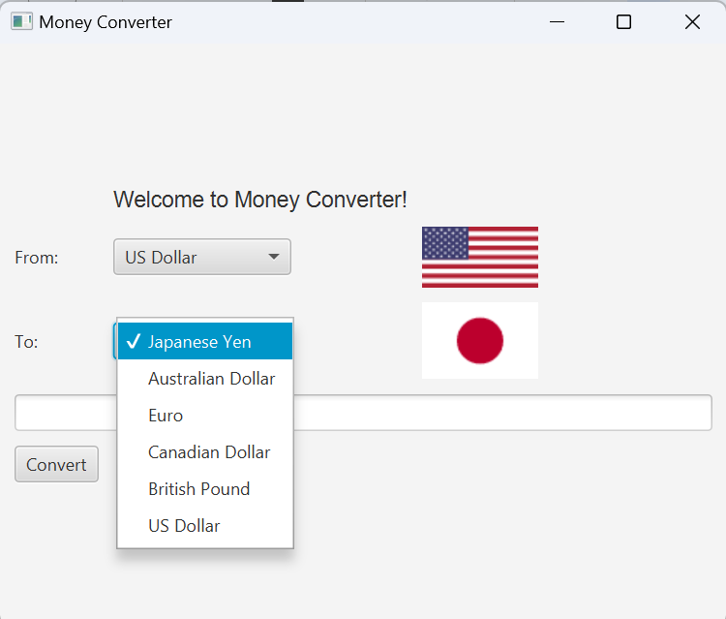

* The second step is clicking on the text box and typing the number of how much of the "from" currency you want to convert to the "to" currency.

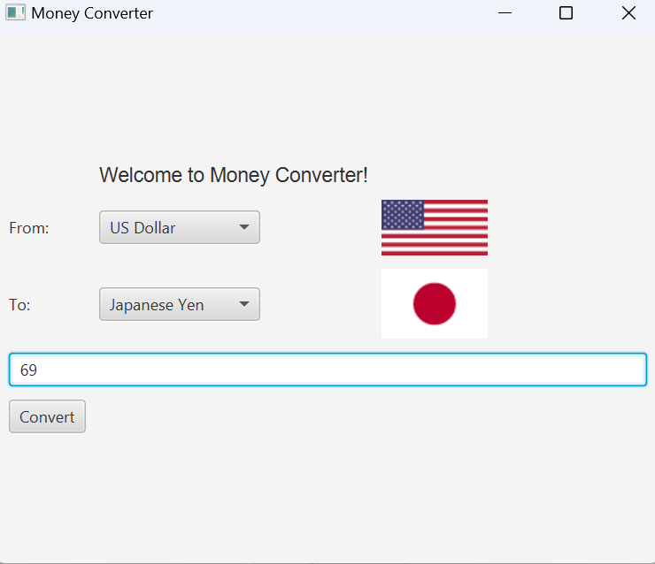

* The third step is to click the convert button and the conversion number will be shown at the bottom of the app.

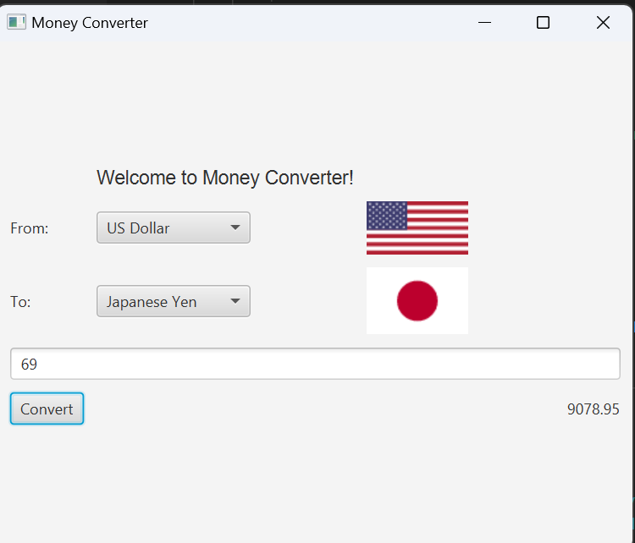

* The final step is to repeat steps 1-3 to convert currencies again.